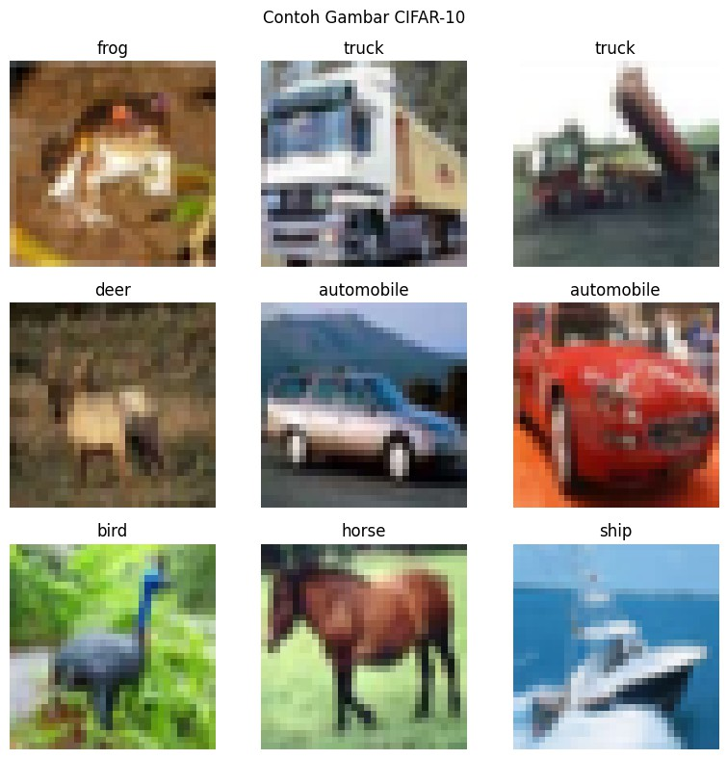
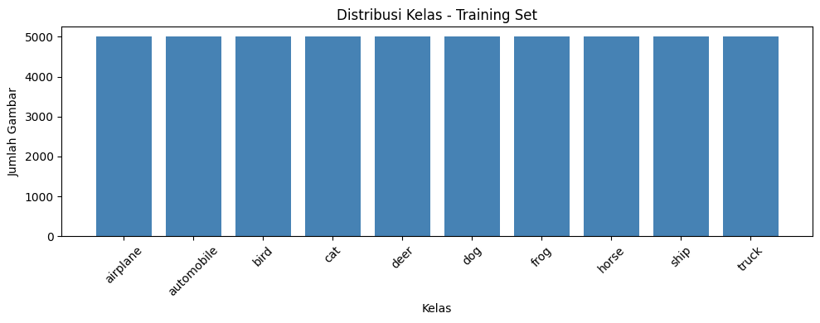
6/21/26, 12:21 PM TK1_Preprocessing_CIFAR10.ipynb - Colab
* Tugas Kelompok 1 - Preprocessing & Eksplorasi Dataset (CNN)
Dataset yang dipake: CIFAR-10
Jadi disini kita nyiapin dataset biar siap diproses ke model CNN, sekalian eksplorasi datasetnya biar ngerti distribusi & karakteristik datanya kayak gimana.
Pembagian kerja kemarin di grup:
1. Import Library - Faiz
2. Load Dataset - Faiz
3. EDA - Andi
4. Preprocessing - Nabila
5. Visualisasi gambar (capture output) - Faisal
6. Laporan - Naura
Note : jalanin dari atas ke bawah ya, tiap orang isi bagian masing-masing dulu terus run ulang semua sebelum disubmit.

* 1. Import Library (faiz)
Library yang dipake taro semua disini biar ga ada yang import ulang-ulang pas nambah kode di bawah. Cell ini juga ngecek versi TensorFlow & ada GPU apa kgk - ini yang discreenshot buat dilampirin ke laporan/visualisasi.

# Library dasar import numpy as np
import matplotlib.pyplot as plt
# TensorFlow / Keras import tensorflow as tf
from tensorflow.keras.datasets import cifar10 from tensorflow.keras.utils import to_categorical
# Cek environment - capture output ini untuk laporan print("TensorFlow version:", tf.__version__)
print("GPU available:", tf.config.list_physical_devices('GPU'))
TensorFlow version: 2.20.0 GPU available: []

* 2. Load Dataset (faiz)
Tinggal load CIFAR-10 pake cifar10.load_data(), abis itu print shape X_train, y_train, X_test, y_test buat mastiin datanya udah kebaca bener.

(X_train, y_train), (X_test, y_test) = cifar10.load_data() print("X_train shape:", X_train.shape)
print("y_train shape:", y_train.shape) print("X_test shape:", X_test.shape) print("y_test shape:", y_test.shape)
Downloading data from https://www.cs.toronto.edu/~kriz/cifar-10-python.tar.gz
170498071/170498071 ━━━━━━━━━━━━━━━━━━━━ 2261s 13us/step X_train shape: (50000, 32, 32, 3)
y_train shape: (50000, 1)
X_test shape: (10000, 32, 32, 3)
y_test shape: (10000, 1)

* 3. EDA - Andi
Tampilin beberapa contoh gambar pake plt.imshow plus label kelasnya, sama liat distribusi jumlah data tiap kelas (pake np.unique atau bar chart juga bisa, terserah). Output gambar dari sini nanti diambil Faisal buat poin Visualisasi.

# EDA - Andi
class_names = ['airplane', 'automobile', 'bird', 'cat', 'deer', 'dog', 'frog', 'horse', 'ship', 'truck']
# Visualisasi contoh gambar plt.figure(figsize=(8, 8)) for i in range(9):
/tmp/ipykernel_596/614433068.py:11: DeprecationWarning: Conversion of an array with ndim > 0 to a scalar is deprecated, and wil plt.title(class_names[int(y_train[i])])

Distribusi kelas: airplane: 5000 gambar
automobile: 5000 gambar
bird: 5000 gambar
cat: 5000 gambar
deer: 5000 gambar
dog: 5000 gambar
frog: 5000 gambar
horse: 5000 gambar
ship: 5000 gambar
truck: 5000 gambar
=== INFO DATASET ===
Total training data : 50000 gambar Total testing data : 10000 gambar Ukuran tiap gambar : 32x32 piksel Channel warna : 3 (RGB) Nilai piksel min : 0
Nilai piksel max : 255

https://colab.research.google.com/drive/1CxtHs4R18iPMT_orT5KPdJH68n51M3dI#scrollTo=vUuOE8DSsaMu&fullscreenOutput=true 1/4

